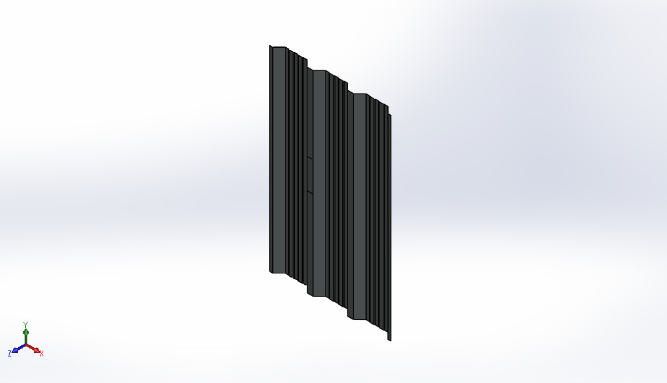
  Simulation of Sheet v1[1]. step
  Date: Saturday, December 30, 2023
  Designer: Sr Muzammil Ejaz & Syed Shayan Ahmed
  Study name: Static 2
  Analysis type: Static
  Table of Contents
  Model Information 2
  Units 3
  Material Properties 3
  Loads and Fixtures 4
  Study Results 5

Model Information

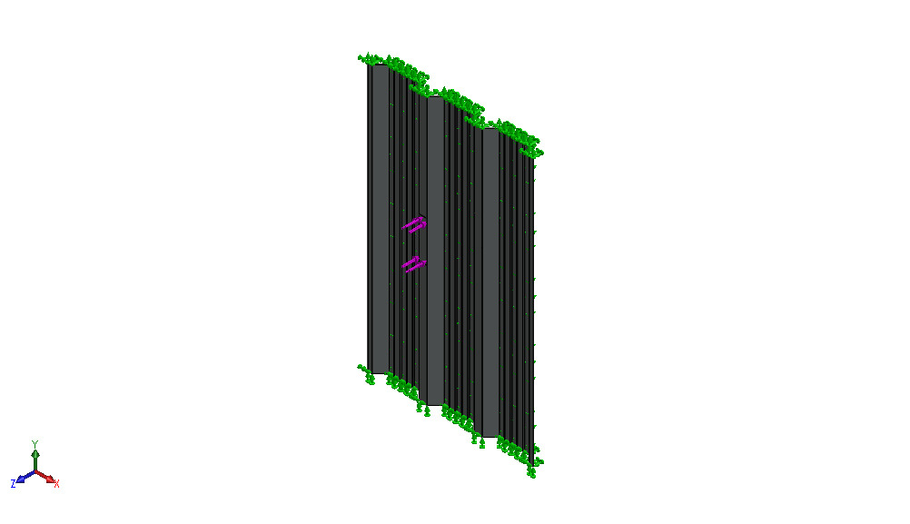
Model name: Sheet v1[1].step
Current Configuration: Default
Solid Bodies
Document Name and Reference | Treated As | Volumetric Properties | Document Path/Date Modified
Split Line2  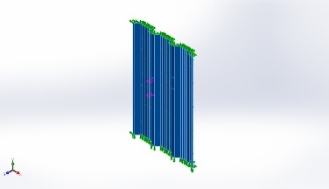 | Solid Body | Mass:2.73499 kg  Volume:0.00035064 m^3  Density:7,800 kg/m^3  Weight:26.8029 N | C:\Users\FC\Documents\Sheet analysis\Sheet v1[1].step.SLDPRT  Dec 29 10:07:16 2023

Units
Unit system: | SI (MKS)
Length/Displacement | mm
Temperature | Kelvin
Angular velocity | Rad/sec
Pressure/Stress | N/m^2

Material Properties
Model Reference | Properties | Components
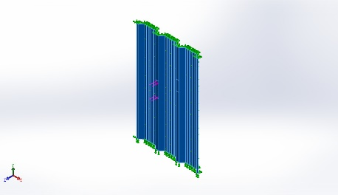 |  | Solid Body 1(Split Line2)(Sheet v1[1].step)
  Name: | Plain Mild Carbon Steel
  Model type: | Linear Elastic Isotropic
  Default failure criterion: | Max von Mises Stress
  Yield strength: | 2.20594e+08 N/m^2
  Tensile strength: | 3.99826e+08 N/m^2
  Elastic modulus: | 2.1e+11 N/m^2
  Poisson's ratio: | 0.28
  Mass density: | 7,800 kg/m^3
  Shear modulus: | 7.9e+10 N/m^2
  Thermal expansion coefficient: | 1.3e-05 /Kelvin
Curve Data:N/A

Loads and Fixtures
Fixture name | Fixture Image | Fixture Details
Fixed-1 | 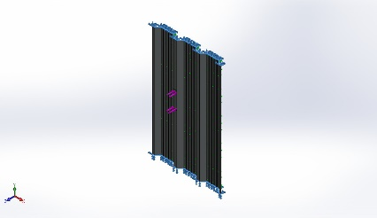
  Entities: | 2 face(s)
  Type: | Fixed Geometry
Resultant Forces
Components | X | Y | Z | Resultant
Reaction force(N) | 5.05447e-05 | 0.000123978 | -0.500951 | 0.500951
Reaction Moment(N.m) | 0 | 0 | 0 | 0

Roller/Slider-2 | 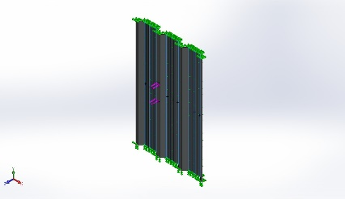
  Entities: | 9 face(s)
  Type: | Roller/Slider
Resultant Forces
Components | X | Y | Z | Resultant
Reaction force(N) | 24.554 | -18.8331 | 1,535.81 | 1,536.12
Reaction Moment(N.m) | 0 | 0 | 0 | 0

Load name | Load Image | Load Details
Force-1 | 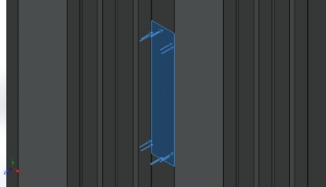
  Entities: | 1 face(s)
  Type: | Apply normal force
  Value: | 1,500 N

Study Results

Name | Type | Min | Max
Stress1 | VON: von Mises Stress | 5.095e+04N/m^2  Node: 23258 | 5.157e+07N/m^2  Node: 22623
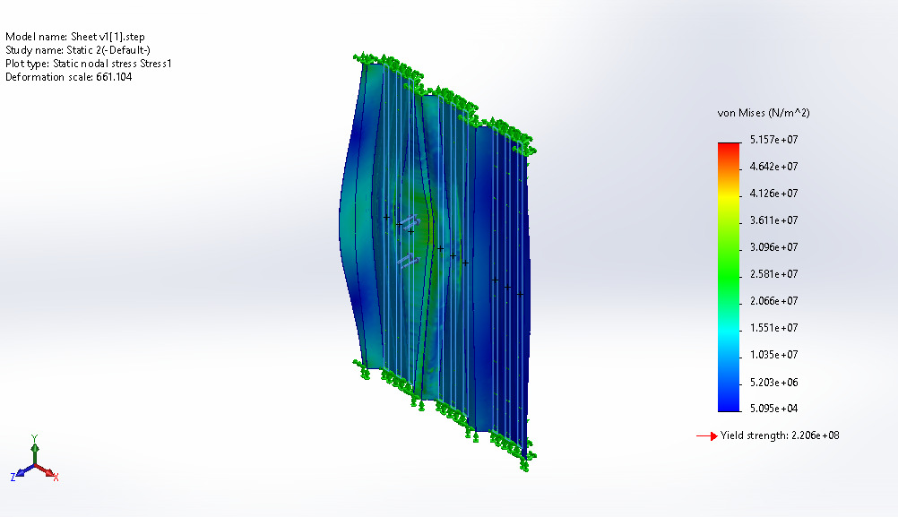
Sheet v1[1].step-Static 2-Stress-Stress1

Name | Type | Min | Max
Displacement1 | URES: Resultant Displacement | 0.000e+00mm  Node: 2 | 1.513e-01mm  Node: 31579
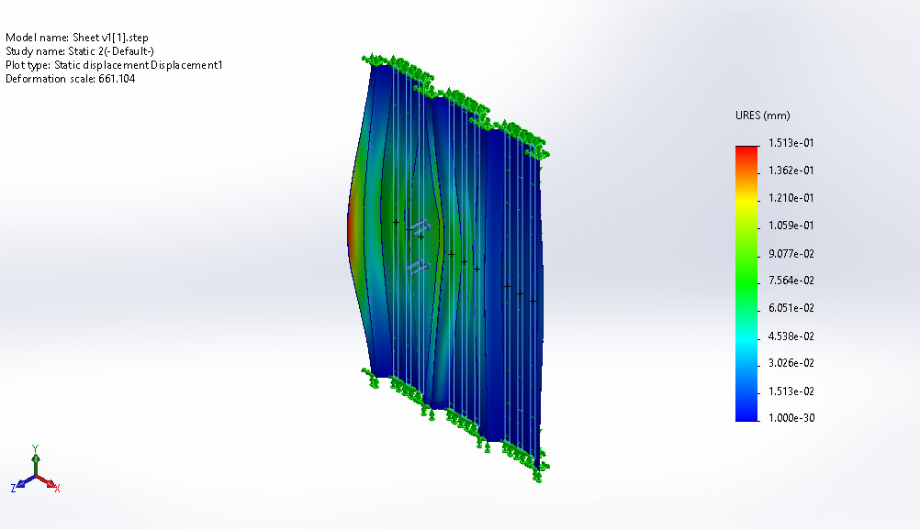
Sheet v1[1].step-Static 2-Displacement-Displacement1

Name | Type | Min | Max
Strain1 | ESTRN: Equivalent Strain | 2.901e-07  Element: 15964 | 1.577e-04  Element: 15772
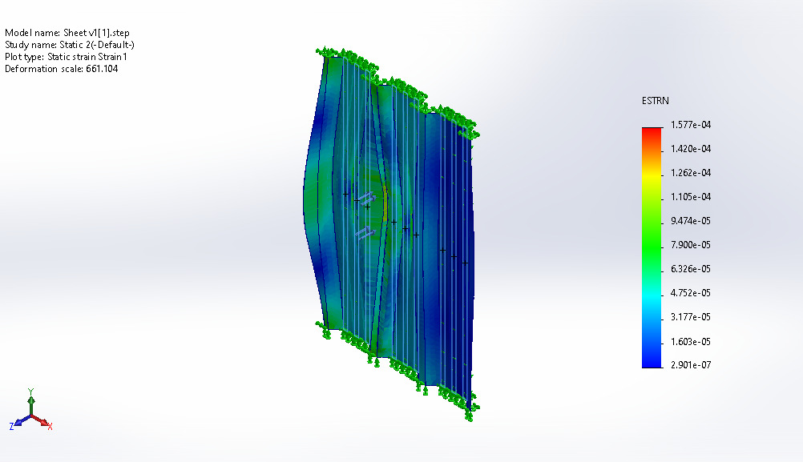
Sheet v1[1].step-Static 2-Strain-Strain1

